Emulating a USB Driver Notes
Christopher Kalitin

USB 2.0 Specification:
https://www.usb.org/document-library/usb-20-specification

DDR = Double Data Rate = sending data on both rising and falling edges of a reference clock.

240MHz DDR signaling for 480MHz data transfers? Too fast for ESP32?

From Platformio Upload:

There’s some hope:
“Full-Speed (FS) and Low-Speed (LS) USB transfers are not directly supported by the HSIC interface (a HSIC enabled hub can provide FS and LS support, as well as IC_USB support)”

1.2V signal standard.

HSIC is an inter pcb technology? Yes. Chip to Chip. Yea I’m looking at the wrong thing.

usb_20.pf:
Low Speed: 10-100 kb/s
Full Speed: 500 kb/s - 10 Mb/s
High Speed: 25-400Mb/s

Peripherals share bandwidth through a host-schedule, token-based protocol.

Tokens might make this easy? Probably not still.

Max 7 Layers of hubs (including root).

“The USB is a polled bus. The Host Controller initiates all data transfers.”
Nah this is gonna be extremely difficult

Token packet specifies direction of data transfer.

4 data flow types:
- Control Transfers (startup)
- Bulk Data Transfers (Burst)
- Interrupt Data transfers (More timely and reliable)
- Isochronous Data Transfers (Occupy a prenegotiated amount of bandwidth, streaming real time transfer)

USB Hubs separate full/low speed signaling from the environment with high-speed signaling? Optional feature? 127 max devices for one host controller.
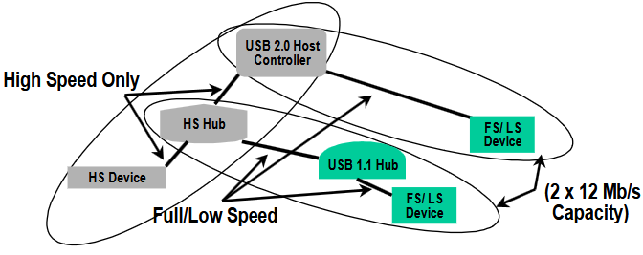

Host Controller Driver: Software interface between the USB Host Controller and USB System Software. Allows for many Host Controller implementations and one USB Driver to support all of them.
USB Driver: USB System Software to Client Software

Looks like I’m making the USB Bus Interface (Includes Host Controller and SIE (Serial Interface Engine)) and the USB System Software (manages devices).

Each USB Endpoint has different characteristics. Bus access frequency/latency requirement; bandwidth requirement; endpoint number; error handling behaviour requirements; max packet size for send or receive; transfer type; transfer direction.

Endpoint Zero is the default control method.

Pipes:
Stream: Data with no USB-defined structure.
Message: Data with some USB-defined structure.

Full/low speed buses have a 1 millisecond frame while full speed buses have a 125 microsecond microframe. You can have many transfers per microframe, microframes define isochronous and interrupt transfers.

